Felv Cats
They deserve a chance!
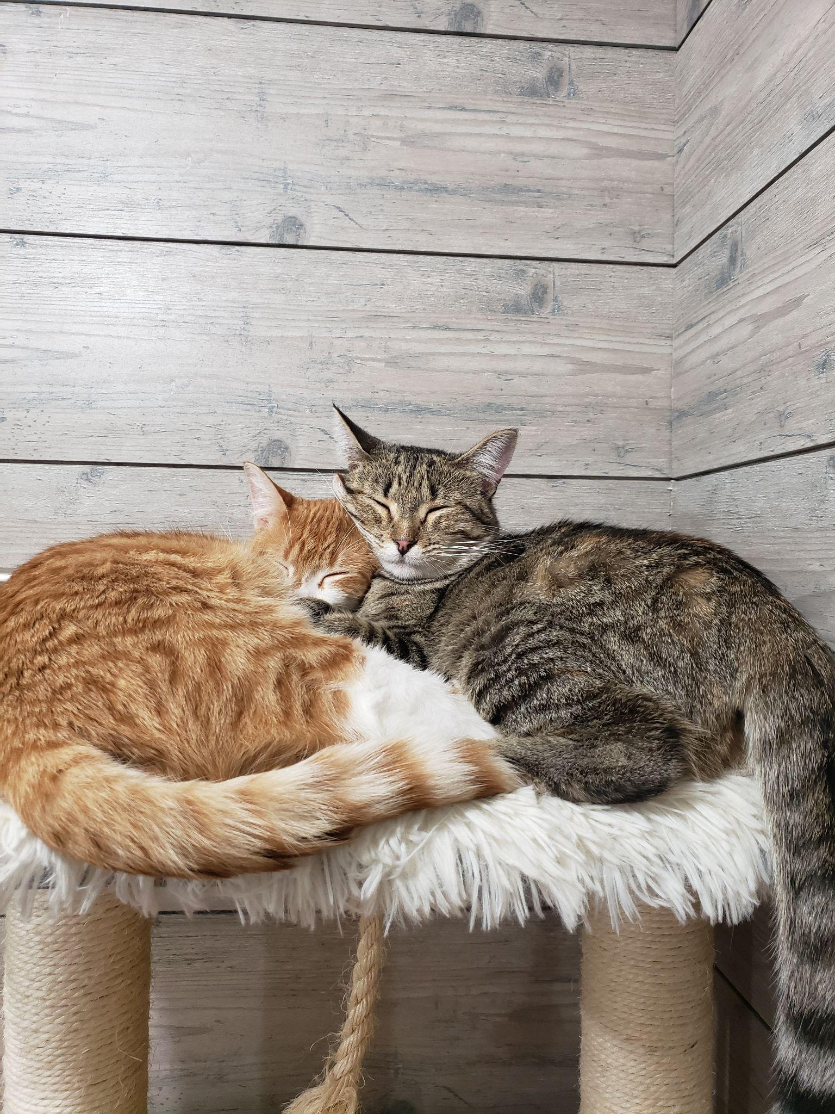
sid@smileysrescues.com
www.smileysrescues.com
Feline Leukemia Virus (FeLV) - Symptoms & Treatment | petMD | PetMD

What is Felv?
Felv, also known as Feline Leukemia, is a disease that impairs the cat's immune system and can cause cancer. Cat leukemia is usually contracted from cat-to-cat transmission (e.g., bites, close contact, grooming and sharing dishes or litter pans). It can also be transmitted to a kitten at birth or through the mother's milk. Kittens are much more susceptible to the virus, as are males and cats that have outdoor access.

Preventions & Info
Unfortunately, 85% of cats with FeLV die within three years of diagnosis.There is no treatment or cure for feline leukemia. Treatment is directed at symptoms and often includes steroids, blood transfusion and supportive care when necessary. Felv+ cats deserve just as much attention and love as any other cats do. You would be incredibly lucky to love one of these babies.

What are some preventions for Felv?
- Felv Vaccinations
- Keep cats indoors at all times
- Get new cats tested (at your vet)
- Keep new cats away from you current, healthy non-felv cats

