Why I shouldn’t Declaw my cat
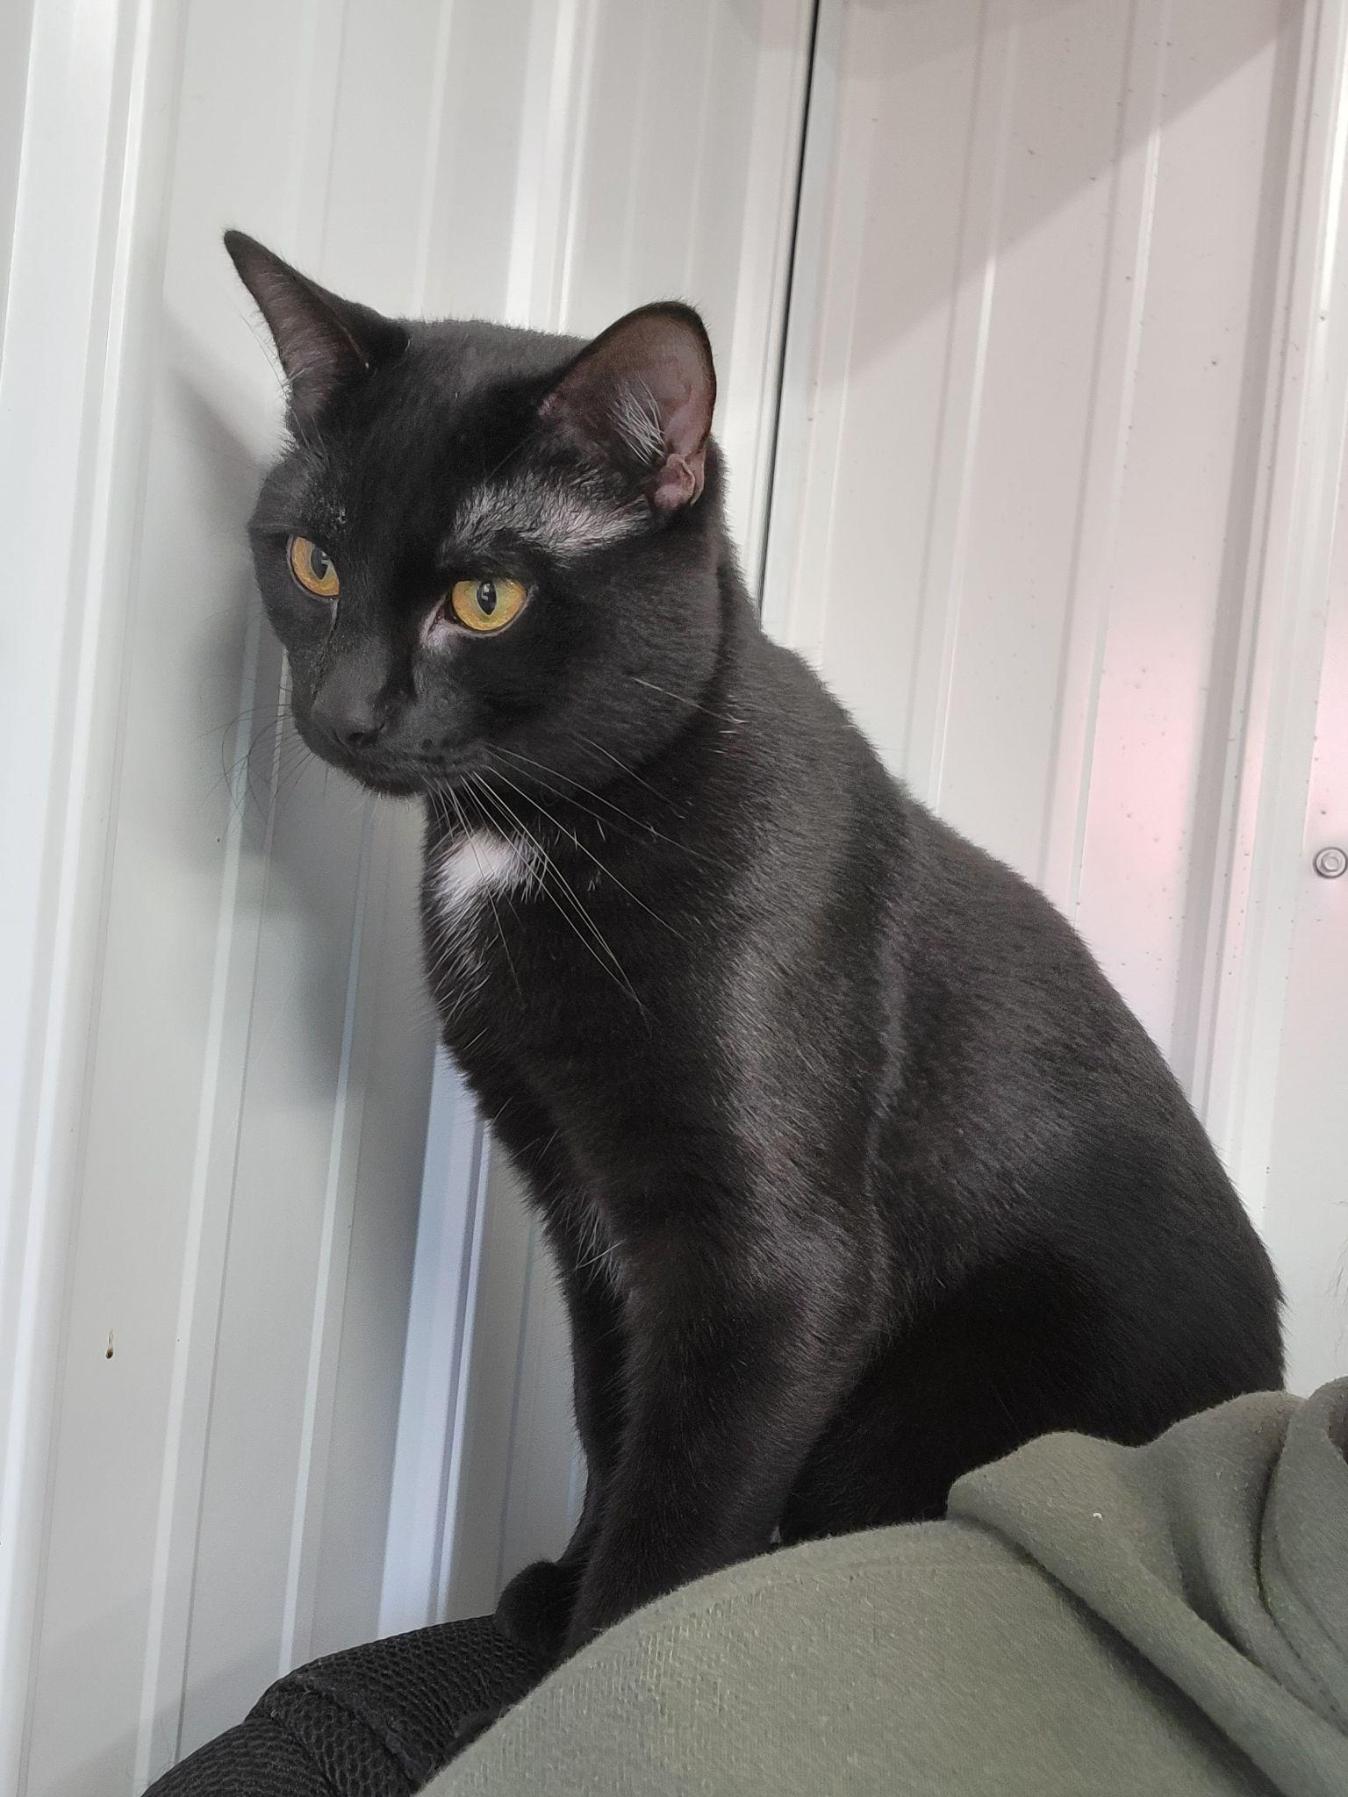
www.smileysrescues.com
sid@smileysrescues.com

Behavioral Issues w/ Declaw
Although it does not happen to all, many cats experience extreme physical pain and will not use the litter box and urinate outside the box.

Other Methods Besides Declawing
- Nail Caps- amazon, chewy & pet stores
- Feliway Deterrent Spray- amazon, chewy
- Get a scratching post- found everywhere
- Feline Deterrent Tape- amazon
- Clipping - this is a great no-cost option. Be very careful when you are first trying this to never clip too much.

What does declawing do to my cat?
- Pain, Pain, and more Pain
Declawing is a surgical procedure that involves amputation of the last bone in the knuckle of each toe on your cat.
- Declawed cats are much more likely to bite (using this as their only defense).
- They are much more likely to not use the litter box anymore. Out of pain they begin to urinate wherever is comfortable.
- Cats are not able to defend themselves as effectively. Claws are a cat's natural defense mechanism. When claws are removed they are not able to defend themselves if they accidentally get outside.

